Standard Operating Procedure (SOP)

Printer Setup for MPCM
Document Reference: CEPT
Equipment: Dot Matix Printer
Version: 1.0.1
Date: July 2025

Purpose
This SOP provides step-by-step instructions for setting up and configuring the Printer for MPCM receipt printing operations.

Scope
This procedure applies to all personnel responsible for installing, configuring, and maintaining MPCM receipt printing systems

Required Materials
- Dot Matrix Printer
- USB Cable
- MPCM sticker paper/receipt roll
- ReceiptPrinterService.msi installation file
- Computer system with administrative privileges

Procedure

Physical Setup and Connection
Initial Connection
- Connect the Dot Matrix printer to the computer system using the provided USB cable
- Power on the printer using the main switch
Removing of additional printers which are connected to System
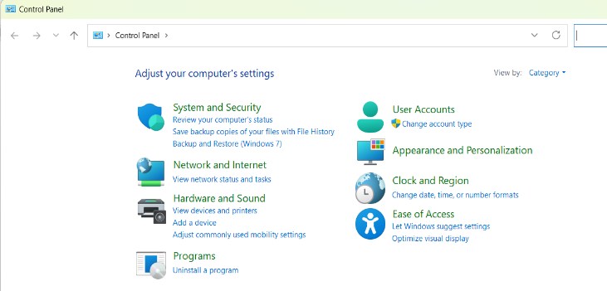
- Go to Control panel

- Click on Hardware and Sound

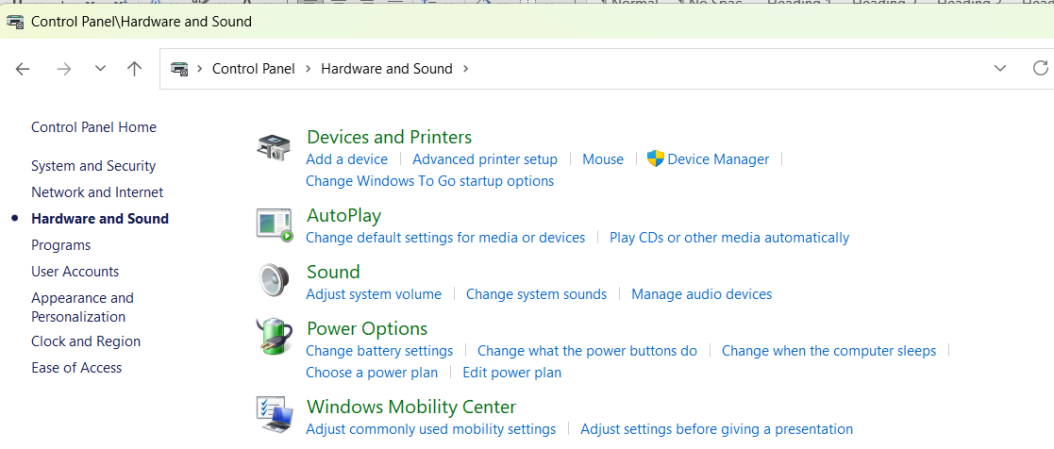

- Click on Devices and Printer
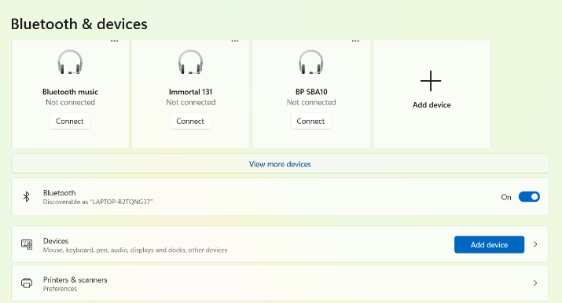

- Click on Printers & Scanners
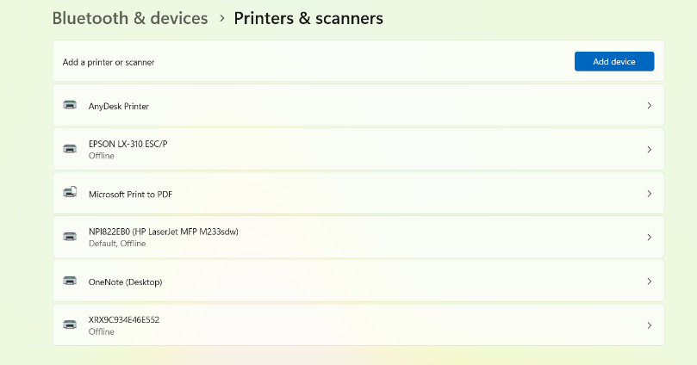

- Remove all unnecessary printers available in above screen shot. You can keep Microsoft print to PDF and network printers
- Install required Dotmatrix software

- Download the MPCM Printer software developed by CEPT from below mentioned link as on when updated

https://drive.google.com/drive/folders/1YdHpJLRzi7R946qxP8LB7Wj-3irn7mTl

- Do the required paper settings and margins for MPCM Receipt printing
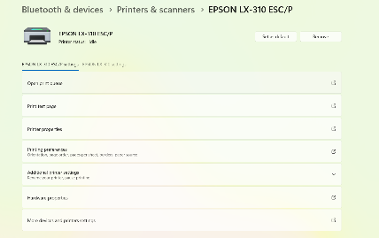
- Go check the status of printer if Offline , switch on printer then the offline will disappear

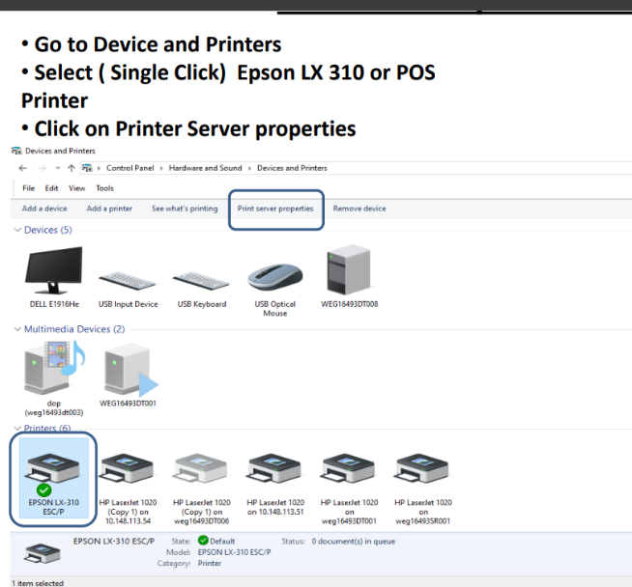
Printer Server Configuration

Form Creation
- Access Printer Server Settings
- Create a new form named "MPCM Receipt"

• Click on Create New form
• Rename the Form as MPCM Receipt
• Configure the form dimensions according to MPCM receipt specifications
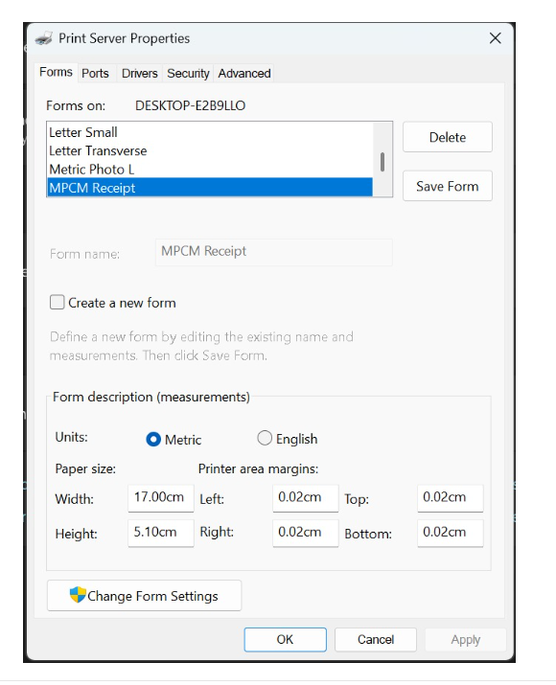

- Give margins as shown below and click on Save Form
  - Paper Size: Width: 17.00cm, Height: 5.10cm
  - Printer Area Margins: Left: 0.02cm, Right: 0.02cm, Top: 0.02cm, Bottom: 0.02cm
  - Units: Metric
- Ensure margins are optimized for MPCM receipt format
- Click "Save Form" to save the configuration

- Go to control panel – >Printers - > Right click on Default dot matric Printer
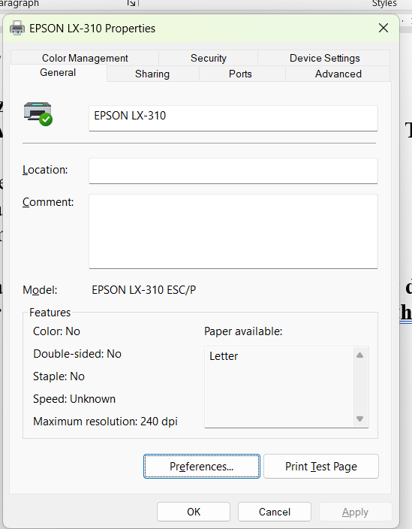
- Click on printer properties – The screen will appear like this
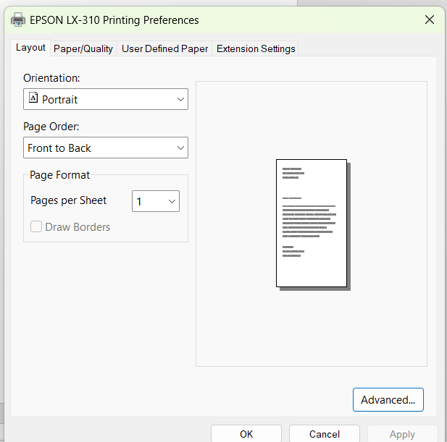

- Click on Advance – The screen will appear this . Then change the following
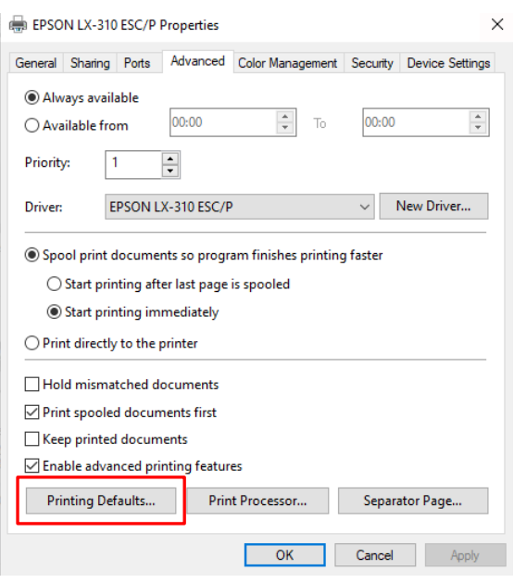
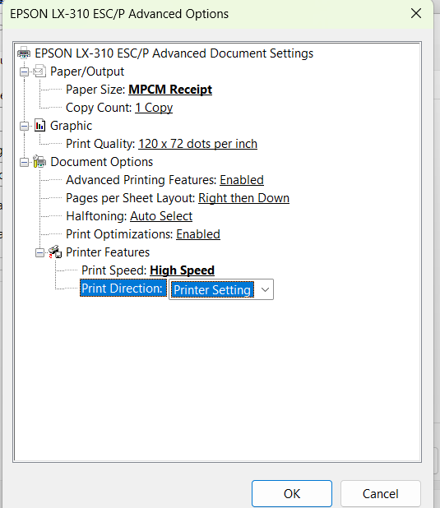

Right Click on the Printer- Properties-Advanced-Printing Defaults-Advanced • Select Paper Size- MPCM Receipt.

- Again goto Device and printer in control panel and Right click on Printer and got to Printer Properties and click o Printing preferences and Check for Paper Source.
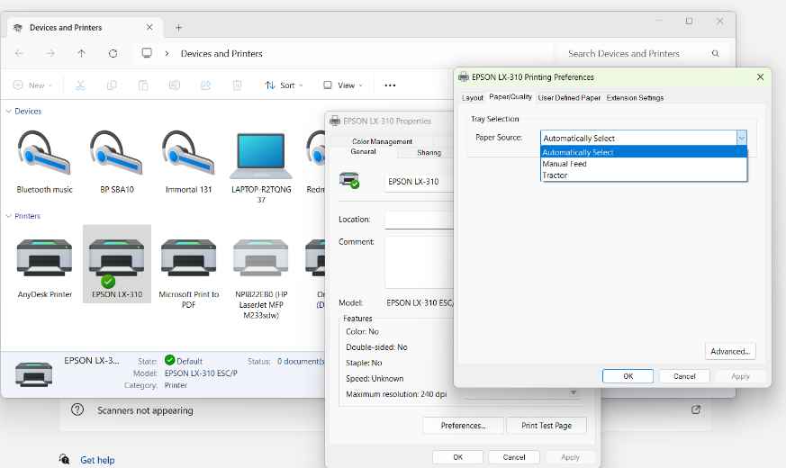

Step 2: Paper Loading
- Feed the MPCM sticker paper through the spooler roller ONLY
- Ensure the MPCM sticker paper is properly locked with the roller mechanism
- Verify that the paper is seated correctly and securely
Phase 2: Driver Installation and Configuration
Step 3: Driver Setup
- Check if printer drivers are installed on the system
- If not installed, install the appropriate printer drivers
- Set this printer as the default printer in system settings

Step 4: Initial Testing
- Perform a test print to verify basic printer functionality
- Ensure print quality and alignment are satisfactory

Phase 3: Service Installation
Step 5: Service File Preparation
- Download the ReceiptPrinterService.msi file
- Copy the file to either:
  - Desktop, OR
  - D: drive root directory
Step 6: Service Installation
- CRITICAL: Install the ReceiptPrinterService under Administrator privileges
- Right-click on the .msi file and select "Run as administrator"
- Follow the installation wizard prompts
Step 7: Service Verification
- After installation, verify that the service is running:
  - Open Windows Services (services.msc) in command prompt
  - Locate the ReceiptPrinterService in the services list
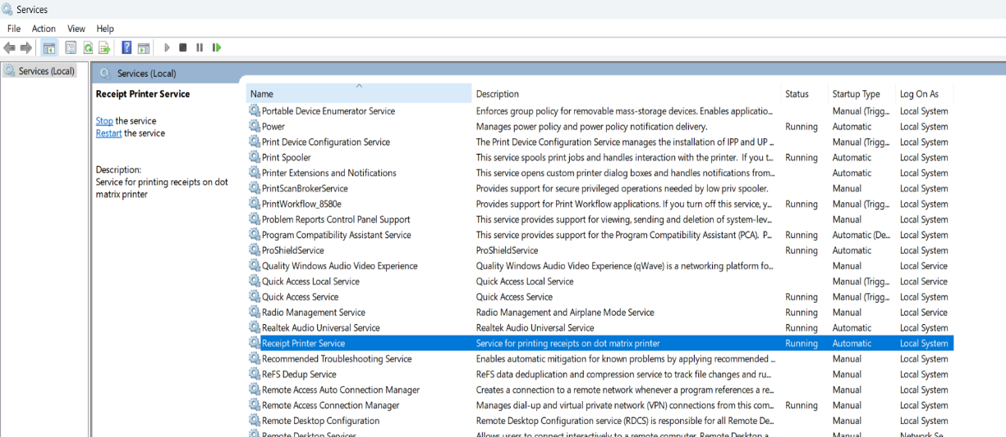
  - Verify the service status shows as "Running"
Step 8: Service Configuration
- In the Services list, locate the ReceiptPrinterService
- Right-click and select "Properties"
- Navigate to the "Log On" tab
- Configure the service to "Run as administrator"
- Apply changes and restart the service if necessary

Phase 4: Printer Server Configuration
Step 9: Form Creation
- Access Printer Server Settings
- Create a new form named "MPCM Receipt"

• Click on Create New form
• Rename the Form as MPCM Receipt
• Configure the form dimensions according to MPCM receipt specifications
Step 10: Margin Settings

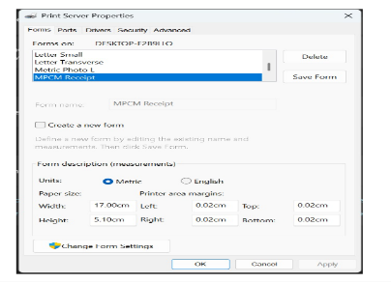

- Apply page margin settings as specified in the reference documentation:

  - Paper Size: Width: 17.00cm, Height: 5.10cm
  - Printer Area Margins: Left: 0.02cm, Right: 0.02cm, Top: 0.02cm, Bottom: 0.02cm
  - Units: Metric
- Ensure margins are optimized for MPCM receipt format
- Click "Save Form" to save the configuration

Phase 5: Final Setup and Testing
Step 11: Paper Management
- Always maintain receipt paper in roll format within the printer
- Ensure paper is properly fixed in the spokes of the spooling roller
- Verify paper alignment and tension

Step 12: Automatic Operation Verification
- Test the automatic sensor functionality
- Confirm that the sensor stops after printing one receipt
- Verify that the paper positioning allows for easy manual tearing
- Test the tear-off mechanism for clean separation

Visual Reference Guide

Key Components Identification
- Control Panel: Located on the front of the printer with status LEDs (Power, Draft, Roman, Sans Serif) and control buttons (Tear Off, LF/FF, Load/Eject, Paper Out)
- Paper Feed Mechanism: Internal rollers and spooler system visible when printer cover is open
- Tractor Feed: Blue clips on sides for securing continuous form paper
- USB Connection: Located on the back/side of the printer for computer connectivity

Proper Paper Alignment
- Continuous form paper should feed smoothly through the tractor mechanism
- Perforations should align properly for clean receipt separation
- Paper tension should be adequate but not too tight to avoid jams

Form Configuration Settings
- Form Name: "MPCM Receipt"
- Metric units preferred for precise measurements
- Minimal margins (0.02cm) for maximum print area utilization
- Standard receipt dimensions optimized for MPCM requirements
Before completing the setup, verify the following:
- [ ] Printer physically connected and powered on
- [ ] MPCM paper properly loaded and locked
- [ ] Printer drivers installed and set as default
- [ ] Test print completed successfully
- [ ] ReceiptPrinterService installed under admin privileges
- [ ] Service running and configured properly
- [ ] MPCM Receipt form created in printer server
- [ ] Margin settings applied correctly
- [ ] Paper roll properly positioned in spooling roller
- [ ] Automatic sensor functioning correctly
- [ ] Paper tear mechanism working smoothly

Troubleshooting

Common Issues and Solutions
Issue: Printer not recognized by system
- Solution: Reinstall printer drivers and check USB connection
Issue: Paper jam or feeding problems
- Solution: Ensure paper is loaded through spooler roller only; do not use manual roller knob when printer is on
Issue: Service not running
- Solution: Verify admin installation, check service configuration, restart service
Issue: Incorrect print formatting
- Solution: Verify MPCM Receipt form settings and margin configurations
Issue: Sensor not stopping after one receipt
- Solution: Check paper positioning in spooling roller spokes

