SOP

Advanced Postal Technology (APT)

FOR

SHIFT END AND SHIFT END REVERSAL AT MAIL OFFICES(DO)
index
Table of Contents
1 Introduction 5
2 Role Details 5
3 Shift End at DO level in Mail Office (MO) 5
4 Shift End Reversal at D.O level in Mail Office (MO) 6

ABBREVIATIONS
Sl. No. | Abbreviation | Description
1 | APT | Advanced Postal Technology
2 | DH | Divisional Head
3 | ASP | Assistant Superintendent of Post Offices
4 | HQ | Head Quarters
5 | CO | Circle Office
6 | DO | Divisional Office
7 | PA | Postal Assistant
8 | RO | Regional Office
9 | MO | Mail Office

SOP:
SOP Version 1.0 Dated 05.02.2026

DISCLAIMER

The operational procedure provided in this SOP is just an illustration for the user for using the APT software solution in an effective manner. If the reader has any doubt in the Department ruling and guidelines, he/she should refer to the respective manuals and volumes only. The APT SOP should not be cited as Rulings.

Introduction

This document defines the workflow and conditions for:

Shift End Reversal at Mail Office (MO)

Shift End at Divisional Office (DO) Level

This process is applicable when a shift is closed incorrectly and needs correction within the allowed time window.

Role Details

Role Code: SOR-DO-CRUD

Role Name: Sorting Division Operator

Shift End at DO level in Mail Office (MO)

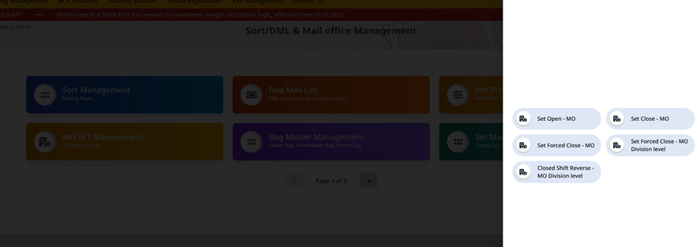

Path: ➡ APT Divisional User Login ➡ Sorting Management ➡ MO SET Management Card ➡ Shift End (MO) – DO Level

This function allows the DO-level user to perform Shift End for a Mail Office without system validation. It is used when operational constraints (such as pending booking articles) prevent normal shift closure.

Note: No validation is performed during Shift End at DO level.

Shift End Reversal at D.O level in Mail Office (MO)
This function allows reversal of a closed shift at the Mail Office level, provided the reversal is initiated within 16 hours of shift begin.
Path: ➡ APT Divisional User Login ➡ Sorting Management ➡ MO SET Management Card ➡ Closed Shift Reversal (MO) – DO Level

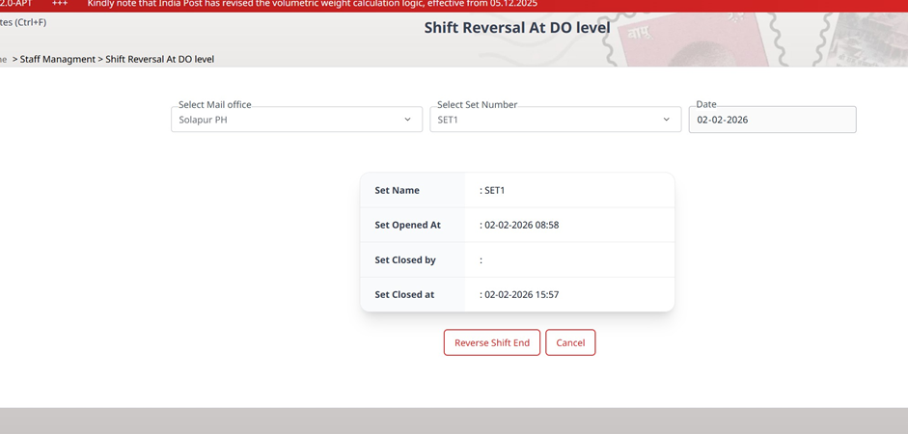

Select the “Mail office”, “Set number” and “Date” from the respective drop down and click on “Reverse Shift end” button.

