Indian Addressing Standard

FOREWORD
The current addressing system in India, while continuously evolving, has limitations largely stemming from the absence of standardization – be it of address formats, reliance on linguistics and human memory, changing administrative boundaries, complexities in reflecting name changes, and dependence on factors that are prone to changes and modifications over consistency. These gaps in address knowledge and information can result in errors or delays in service access. These could have an impact on efficiency in service delivery, increased operational costs from processing delays and work duplication, delayed emergency responses, and user inconvenience.
Therefore, standardization of addresses will be a pivotal step towards adopting a uniform addressing format, thereby enabling a unified, technology-enabled framework with structured, interoperable, and machine-readable address data that can transform governance and service delivery. It is a process of normalizing the use of addresses in a consistent and structured manner, making it more accurate, user-friendly, and efficient for purposes such as logistics, service delivery, communication, legal documentation, emergency response, etc. It will allow addresses across the country to follow a consistent format that meets the rules and requirements set by the regulating authority in the state or region.
Standardized addresses can be used across many disciplines, including government services, disaster and hazard-mapping, urban development, land-use planning, law enforcement, etc. The interests of these disciplines overlap when they require the development of significant, highly precise, and large locational address data sets to support service delivery. Address standardization is a fundamental step in compiling such resources since a substantial fraction of the address information that is collected from various sources (official and unofficial) is either incomplete or ambiguous. Additionally, with standardized address data, different sectors and departments will be able to exchange and interpret address data based on their requirements and needs. Therefore, address standardization would not only enhance efficiency and user convenience but also foster cross-sectoral collaboration, creating a foundational layer for equitable access, responsive governance, and seamless public service delivery.
DIGIPIN is an open-source national level addressing grid developed by the Department of Posts in collaboration with Indian Institute of Technology (IIT), Hyderabad and National Remote Sensing Centre (NRSC), Indian Space Research Organization (ISRO).
This standard shall enable the smooth integration of DIGIPIN into the national addressing system by incorporating geospatial referencing, thereby enhancing precision, validation, and interoperability.

TABLE OF CONTENTS
1 SCOPE 5
2 REFERENCES 5
3 TERMS AND DEFINITIONS 5
3.1 Address 5
3.2 Addressing system 5
3.3 Addressable object 5
3.4 User 5
3.5 Address attributes 5
3.5.1 Unit 5
3.5.2 Floor number 6
3.5.3 Tower/ Block/ Wing/Building Name 6
3.5.4 Premise 6
3.5.5 Area 6
3.5.6 Village 6
3.5.7 Town 6
3.5.8 City 7
3.5.9 PIN code 7
3.5.10 District 7
3.6 Address line 7
3.7 Address location 7
3.8 Address information 7
4 SYMBOLS AND ABBREVIATIONS 7
4.1 Symbols 7
4.1.1 DIGIPIN symbol 7
4.2 Abbreviations 7
5 DIGIPIN 8
5.1 DIGIPIN design 8
5.1.1 Bounding Box 8
5.1.2 Level partition 9
5.2 Grid sizes at various levels 9
6 NATIONAL ADDRESSING STANDARD 9
6.1 Developing a standardized addressing system 10
6.1.1 Addressee information 10
6.1.2 Building information 10
6.1.3 Location information 10
6.2 Address Attributes and Lines 10
6.2.1 Address Attributes 10
6.2.2 Address Lines 11
6.3 Geo-coded addressing identifier 11
6.3.1 DIGIPIN-enabled addressing 11
6.4 Attribute Description 13
6.4.1 Unit (name/number) 13
6.4.2 Floor number and Tower/ Block/ Wing, etc. (name/ number) 15
6.4.3 DIGIPIN 17

Annex A: List of References
Annex B: DIGIPIN Symbol
Annex C: DIGIPIN generation process
Annex D: Illustrations – DIGIPIN-enabled standardized way of writing an address

INDIAN ADDRESSING STANDARD
PART 1: CONCEPTUAL MODEL AND DIGIPIN

SCOPE
This document standard provides the framework for determining address attributes used to describe an addressable object. It specifies requirements and provides guidance on the usage of address attributes, terminologies and semantics, ensuring their applicability across urban and rural systems, and across different land uses.
Through this standard, users shall be able to represent the address information for each addressable object incorporating the latitude and longitude coordinates of the location for precise spatial reference.
This standard does not include ‘Addressee information’, which contains personal information such as c/o (care of), d/o (daughter of), s/o (son of), w/o (wife of), or h/o (husband of), contact details, and other information, which are used typically to further identify or locate the intended recipient.

REFERENCES
The documents listed in Annex A are necessary adjuncts to this address standard. These reference documents are widely recognised as sources of high-quality, reliable, and accurate information for capturing address information, and serve, in part, as informative references for formulating this standard.

TERMS AND DEFINITIONS
For this standard, the following terms and definitions shall apply -

Address
Structured information that allows the unambiguous determination of an object for the purposes of identification and location.

Addressing system
The structured method for collecting and documenting address data to ensure it can be identified and easily accessed.

Addressable object
An object or a physical entity that may be assigned an address.

User
A user refers to any individual, service provider, government entity, or private entity (including but not limited to) that utilises address information.

Address attributes
The individual elements that make up the description of a physical address -

Unit
A unit, for the purpose of this standard, refers to an enclosed space, either as an individual standalone structure or part of a larger structure that is designed to function independently, having its own access, utility, and facility. A unit can be either owned or rented. [example - a plot or khasra, an independent residential house, a flat in an apartment, a single shop, a store in a mall, an individual office building, etc.]

Floor number
A floor number, for the purpose of this standard, refers to the specific level within a multi-storey building where a unit, or space is situated, serving as a reference for identifying vertical positions within the structure. [example- upper ground, first, second, terrace, etc.]

Tower/ Block/ Wing/Building Name
A tower/ block/ wing/building Name, for the purpose of this standard, refers to an identifier for a specific/ separate section, building, part of a building or division within a larger campus or complex. [example - separate departments or hostels within a University campus, a group of flats/ apartments within a residential township, an outpatient department (OPD) wing/ block in a hospital complex, etc.]

Premise
A premise, for the purpose of this standard, refers to a single standalone building, group of buildings or spaces within a defined boundary that together form one single entity. [example - housing complexes, commercial complexes, malls, single office buildings, condominiums, university campuses, hospital campuses, government office complexes, etc.]

Area
An area, for the purpose of this standard, refers to a space within a village, town or city that is defined and notified by the local bodies. [example – locality, colony, neighbourhood, sector, hamlet, phase, pocket, ward, streets, roads, lanes, urban village, etc.]
  - in case of planned areas of a town or city, areas could be defined as colonies, localities, sectors, phases, pockets, etc.;
  - in case of unplanned areas of a town/ city or rural areas, these areas could be identified as neighborhoods, localities, mohallas, etc.;
  - will also include areas notified as ‘urban villages’;
  - may also include an administrative entity like ‘ward’ which is used as an area identifier for the unit/ plot;
  - will also include public pathways or passages, such as streets, roads, or lanes, that act as locational identifiers for a campus/ complex or a unit/ plot.

Village
A rural settlement that is governed by a rural local body and does not meet the criteria of being a Census Town (See the Census of India).

Town
An urban settlement which is classified as follows (See the Census of India):
- Statutory towns: An area that has been officially notified as a statutory town by a state government, through legislation or statutory notification, and is governed by an urban local body. Statutory towns with a population of more than 1,00,000 are classified as ‘Cities’.
- Census towns: An area that is classified as urban only for statistical/census purposes, and that satisfies all three of the following criteria –
  - A minimum population of 5,000 persons
  - 75% and above of the male main working population is engaged in non-agricultural pursuits, and
  - A density of population of at least 400 persons per sq. km.

City
An urban settlement/ statutory town with a population of 1,00,000 and above, and is governed by a Municipal Corporation (See the Census of India).

PIN code
PIN (Postal Index Number) code is a 6-digit code assigned to each delivery post office to streamline mail sorting and delivery.

District
A district (also known as Zilla) is an administrative division of an Indian state or territory. As per the Registration Act 1908, State Government is mandated to form districts and sub-district, and shall prescribe, and may alter, the limits of such districts and sub-districts. The district encompasses territorial areas like villages, towns, and cities.

Address line
"Address lines" typically refer to physical or logical lines constituting the address of an object/ unit. These contain the address attributes, either as a single attribute or as a group of attributes.

Address location
The specific position associated with an address, representing the physical location of the addressable object.

Address information
The structured set of details used to identify and locate a specific place or object, typically for communication, navigation, or service delivery purposes.

SYMBOLS AND ABBREVIATIONS

Symbols
For the purpose of this standard, the following DIGIPIN symbol shall apply:

DIGIPIN symbol

The symbol shall represent the DIGIPIN as officially adopted by the Department of Posts, Government of India. It shall be used as a standardised prefix to the 10-character code to ensure uniform representation, easy identification, and consistent usage across all addressing, communication, and information systems. (Refer Annex B for detailed description)

Abbreviations
The following abbreviations shall apply:
PIN – Postal Index Number
UT – Union Territory
DIGIPIN – Digital Postal Index Number
GIS – Geographic Information System
DPI – Digital Public Infrastructure

DIGIPIN
DIGIPIN is visualised as an offline addressing grid system that assigns a unique 10-digit alphanumeric code that represent 4-meter by 4-meter(approx.) units, derived from the latitude and longitude coordinates of the unit. This alphanumeric code serves as the offline addressing reference for any specific location within the DIGIPIN system. DIGIPIN is a function of the latitude and longitude of the location represented as a grid value.

DIGIPIN design
FIG 1. DIGIPIN GRID DESIGN
The DIGIPIN system is designed to be scalable, adaptable, and can be integrated with existing GIS applications. The design of the DIGIPIN code comprises two key components – the bounding box and the hierarchical level partition. The bounding box covers the entire geographic extent of India, establishing a uniform spatial reference framework. The level partition employs a hierarchical methodology in which the geographic area is systematically and progressively subdivided into increasingly smaller spatial units.
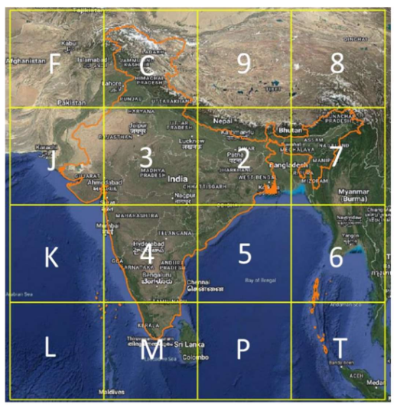
FIG 2. BOUNDING BOX

Bounding Box
The DIGIPIN design process starts with a bounding box, which is split across a 4 x 4 grid, i.e. 16 regions that cover the entire country. Each region is identified and labelled by one of the alphanumeric symbols, i.e. 2, 3, 4, 5, 6, 7, 8, 9, C, J, K, L, M, P, F, T.
- Longitude 63.5 – 99.5 degrees east
- Latitude 2.5 – 38.5 degrees north
- The Coordinate Reference System (CRS) used in the proposed code design is EPSG:4326. Using EPSG:4326 (WGS84 datum at epoch 2005) has several advantages, such as wide recognition and adoption, simplicity and global coverage.

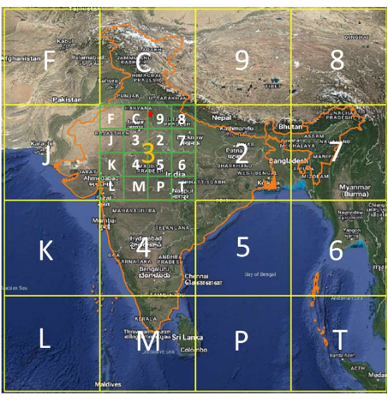
FIG 3. LEVEL PARTITION

Level partition
The first character of the DIGIPIN is indicated by the character from the 16 regions in which the desired location is situated. This is called the Level-1 partition. The Level-1 partition is then subdivided into 16 subregions in a similar fashion.
Each Level-1 partition that is further divided into 16 subregions shall use the same 4×4 schema, with each subregion labelled by the 16 characters, subsequently the Level-2 partition. The second character of the DIGIPIN identifies the subregion within the selected Level-2 region that contains the desired location. Together, the first two characters specify one of the 16^2 = 256 subregions. This is called the Level-2 partition.
In the same way, the next eight levels apply identical subdivisions and labelling steps, with each new character further refining the location. After all the ten levels are completed, the resulting 10-character code, i.e. the DIGIPIN, will uniquely identify a single cell out of the 16^10 cells within the bounding box.
A full and comprehensive procedure for generating the DIGIPIN of a particular location is detailed in Annex C.

Grid sizes at various levels
DIGIPIN is generated through a sequence of iterative processes. At Level-1, the bounding box is divided into 16 (4x4) regions. The total latitudinal and longitudinal width of the bounding box is 36°, resulting in 9° x 9° regions at Level-1. Similarly, at Level-2, each 9° x 9° region is further divided into 16 (4 x 4) sub-regions, resulting in 2.25° x 2.25° regions. The same process is carried out up to 10 levels. The table below shows a relation between the DIGIPIN code length, the corresponding grid size and approximate linear distance at the equator. It gives an estimate of the positional uncertainty associated with DIGIPIN code length. For instance, a DIGIPIN code of length 6 represents a ~ 1km x 1km region. It requires an additional 4 digits to precisely locate a 3.8m x 3.8m region inside this region.
Table 1 - DIGIPIN grid size at different levels
(Clause 5.2)
Core length | 1 | 2 | 3 | 4 | 5 | 6 | 7 | 8 | 9 | 10
Grid width | 9º | 2.25º | 33.75′ | 8.44′ | 2.11′ | 0.53′ | 0.13′ | 0.03′ | 0.5′′ | 0.12′′
Approx. distance | 1000 km | 250 km | 62.5 km | 15.6 km | 3.9 km | 1 km | 250 m | 60 m | 15 m | 3.8 m

NATIONAL ADDRESSING STANDARD
The geocoded national addressing system for India is based on the understanding that an address is made up of a set of one or more address attributes. A uniform framework for the structuring, formatting, and writing of addresses shall be established to ensure clarity, consistency, and accuracy in the representation of address information across platforms, sectors, and systems. It will also define and specify the associated attributes, and specify the structure and sequencing of address lines required to conform to the standard address format.

Developing a standardized addressing system
Every addressable object shall be assigned an address, irrespective of whether it is individually or jointly owned, part of a larger complex or a standalone structure, located in a planned or unplanned area, or situated in an urban or rural environment.
The constituent components of an address have been derived to form a comprehensive structure and addressing framework that ensures accurate identification of addressable objects and facilitates efficient service delivery, as detailed below -
- Addressee information identifies the intended addressable object,
- Building information specifies the physical premises associated with addressable object, and
- Location information provides the broader geographic and administrative area.
Each constituent part plays a distinct but interrelated role in enabling consistent, reliable, and interoperable address representation across systems and services.

Addressee information
An addressee information is a set of information intended for the recipient of a good or service, who is expected to receive, acknowledge, or act upon the good or service. It can be an individual, organization or entity for whom a good or service is specifically intended, such as the name of the individual, a designation or title, contact details, and other addressable object identifying elements.
*Addressee information is not within the scope of this standard.

Building information
The building information refers to the physical structure (such as building, multistoried apartment, property, etc.) representing the addressable object. This can include details such as unit number (including plot number), floor level, tower number/name, or any other relevant identifier that can be used to uniquely distinguish a building or part of a building from another. For instance, multiple addressable objects may share the same locational address, but occupy different units or floors within a high-rise structure.

Location information
The location information represents the broader geographic or administrative area within which the address is situated, linking descriptive addresses to exact physical location on the earth’s surface. It provides the spatial reference required for effective routing and navigation, allowing service delivery to maneuver and reach the intended destination. Details of location can traditionally include name of campus/complex, area name, locality, neighbourhood, city, town, village, district, PIN code, state and Country. However, DIGIPIN sets the foundation for the integration of location-based GIS information and spatial mapping.

Address Attributes and Lines
The following standard address attributes for capturing, recording, and storing address data provides guidance on how address lines shall be structured and documented.

Address Attributes
An address attribute is specified information that is used to uniquely identify an addressable object. An address is made up of a set of one or more attributes capturing both the building information as well as locational information.

Address Lines
Address lines typically refer to physical or logical lines constituting the address. These contain the address attributes, either as a single attribute or as a group of attributes. The aforementioned address attributes shall be represented in the following sequence.
Table 2 - Address line – Format
(Clause 6.2)
Line | Address attribute
Address Line 1 | Unit (name/number), Floor number
Line 2 | Tower/ Block/ Wing/ Building (name/number)
Line 3 | DIGIPIN

Geo-coded addressing identifier
Geocoding Addresses refers to a GIS operation that translates or converts an address or a text-based description of a location into spatial data that can be displayed as features on a map, by referencing the address attributes from a street centerline, point or polygon reference layers.

DIGIPIN-enabled addressing
The DIGIPIN contains precise geographic coordinates that can be used to derive associated locational attributes—such as the premises name, street or area, village/town/city, state, and country— through integration with authoritative geospatial GIS data layers. DIGIPIN as a spatial reference enables navigation to the exact location of the addressable object, eliminating the need to manually enter these locational attributes. Consequently, the address entry process is streamlined by requiring users to provide only the building information, such as floor number, unit number, and tower/block/wing/building name, along with DIGIPIN. This is particularly transformative in rural or informally addressed areas, where traditional addresses are often imprecise with navigational reliance on landmarks, family relevance (e.g., “near the temple” or “opposite the Panchayat office”), or natural features. By enabling a location-based identifier, DIGIPIN transforms how addresses are captured and used, ensuring consistency, accuracy, and accessibility across diverse geographic contexts.
The following table presents the ‘DIGIPIN-enabled Addressing’ format that represents the addressing standard, designed to be minimalistic and fully capable of integrating the DIGIPIN for seamless, machine-readable addressing and processing.
Table 3 - DIGIPIN – enabled Addressing
(Clause 6.3)
 | Sl.no. | Address attributes | Purpose
BUILDING  INFORMATION | 1 | Unit (name/number) | - indicates the specified alpha-numeric identifier or the name of the addressable object such as house name/ number, plot number, khasra number, shop number, door number, room number, etc.
BUILDING  INFORMATION | 2 | Floor number  and/or  Tower/ Block/ Wing / Building, etc.  (name/ number) | - (floor no.) indicates the specific level or storey of a building in which the unit is located, usually counted from the ground up  - (tower no.) indicates the specific tower/ block/ wing/building within a larger complex/ campus, in which the addressable object is located  - it will also include the building name, in case of a single standalone building;
LOCATIONAL  INFORMATION | 3 | DIGIPIN | - indicates the geocoded spatial reference of the addressable entity will be able to interact with other authoritative geocoded databases to generate one or more of the following for an address:  - information of the premise (name of the campus / complex information) (if any);  - information of the area (name/ number of the locality, sector, phase, pocket, ward, neighborhood, street, road, lane, etc.);  - information of the village/ town/ city (name of the village/ town/ city in which the unit is located)  - information of the district (name of the district in which the unit is located)  - information of the PIN code (PIN code/ of the area in which the unit is located)  - information of the State/ UT (name of the State/ UT in which the unit is located)  - information of the Country (name of the Country in which the unit is located, will be applicable particularly in case of international posts)
The figure below shows the prescribed format for capturing and recording address information using DIGIPIN-enabled addressing attributes -
FIG 4. DIGIPIN-ENABLED ADDRESS FORMAT

Attribute Description
For the representation of each address attribute detailed requirements are specified. It specifies how various address attributes shall be written, formatted, and interpreted to ensure consistency, clarity, and accuracy in address representation across different use cases and systems, which will eliminate ambiguity, support data interoperability, and improve service delivery (refer Annex D for detailed illustrations)

Unit (name/number)
It is the identifier representing the addressable unit. It can be a number, a name or a combination of both.

Unit number

Definition
It is the numerical identifier that is uniquely associated with the unit such as house, flat, land parcel, plot, khasra, shop, room, door, etc.

Characters in unit number
Unit number shall be defined using standard alphanumeric characters. | 34A  B36 | [Correct]  [Correct]

Prefixes of unit number
A unit number may be preceded by a prefix, such as ‘Plot’, ‘Room’, ‘House’, ‘Villa’, ‘Flat’, ‘Shop’, ‘Door’, etc. The terms like ‘Number’ or ‘No.’ after the prefix shall not be used. | House 12  12  House No. 12  H. No. 12 | [Correct]  [Correct]  [Incorrect]  [Incorrect]

Numerals in unit number
Numerals used in the unit number shall be expressed using Arabic numerals (e.g. 1, 2, 3). Roman numerals, spelled-out numbers, or any other numeral system shall not be used. | Room 3  Room III  VIII | [Correct]  [Incorrect]  [Incorrect]

Integers in unit number
Unit number shall be represented as positive integers only. Zero (0), leading zeros (e.g., 01, 002), or decimal values (e.g., 1.5) shall not be used. | Room 5  Room 05 | [Correct]  [Incorrect]

Alphabets in unit number
The alphabets in the unit number shall be in upper case. | 34A  34a | [Correct]  [Incorrect]

Official unit number
Only officially assigned unit numbers shall be used. Where no official unit number exists, the relevant authority shall assign one according to applicable guidelines.

Punctuations in unit number
Punctuations in unit number shall be limited to the forward slash [/] and hyphen [-]. | 18/6  F-208 | [Correct]  [Correct]

Multiple unit numbers
i) | If an addressable object spans multiple unit numbers, the unit numbers shall be represented within a single consolidated name using only the permitted separators: a hyphen (–) for consecutive unit numbers and a forward slash (/) for non-consecutive unit numbers. No other separators shall be used. | Shop 1  Shop 1-3  Shop 1/3/5  Shop 1, Shop 2, Shop 3  Shop 1, 2, 3 | [Correct]  [Correct]  [Correct]  [Incorrect]  [Incorrect]
ii) | If an addressable object is a subset of a larger unit, and can be uniquely identified only through a combination of multiple prefixes (e.g., 'Plot', 'Room', 'Flat'), each accompanied by its own identifier, then all such elements shall be included in the address. The elements shall be ordered from the smallest to the largest unit in terms of spatial hierarchy. A comma (,) shall be used to separate each prefix-identifier pair. | Room 302, House D124  Room 302, D124  House D124 Room 302  Flat 4, Plot 32/4  Flat 4 Plot 32/4 | [Correct]  [Correct]  [Incorrect]  [Correct]  [Incorrect]

Unit name

Definition
It is the name identifier that is uniquely associated with the unit such as house, flat, land parcel, plot, khasra, shop, room, door, etc.

Characters in unit name
A unit name shall be defined using standard alphanumeric characters. | Panakathara House  24 Seven | [Correct]  [Correct]

Punctuations in unit name
A unit shall not include punctuations like a full stop [.], hyphen [-], etc. Where the name from which the name of premise is derived includes punctuations, it shall be replaced with a space.  However, an apostrophe [’] may be retained in cases where its removal would alter the intended meaning or grammatical correctness of the name. | Gupta’s Niwas  NN Niwas  N.N. Niwas | [Correct]  [Correct]  [Incorrect]

Floor number and Tower/ Block/ Wing, etc. (name/ number)

Floor number

Definition
It refers to the specific level or storey within a building, typically counted upward or downward (in case of basement) from the ground level.

Characters in floor number
Floor number shall be defined using standard alphanumeric characters. | Floor 4  Floor G  Floor Ground | [Correct]  [Correct]  [Correct]

Prefixes of floor number
Floor number shall be preceded by a prefix ‘Floor’. The terms like ‘Number’ or ‘No.’ after the prefix shall not be used. | Floor 12  Floor No. 12  12  12th Floor  Level 12 | [Correct]  [Incorrect]  [Incorrect]  [Incorrect]  [Incorrect]

Numerals in floor number
Numerals used in floor numbers shall be expressed using Arabic numerals (e.g., 1, 2, 3). Roman numerals, spelled-out numbers, or any other numeral system shall not be used. Suffixes such as –st, –nd, –rd, or –th shall not be included with the numerals. | Floor 6  Floor VI  Floor 6th | [Correct]  [Incorrect]  [Incorrect]

Integers in floor number
Floor number shall be represented as positive integers only. Zero (0), leading zeros (e.g., 01, 002), or decimal values (e.g., 1.5) shall not be used. | Floor 5  Floor 05 | [Correct]  [Incorrect]

Alphabets in floor number
Floor levels that are non-numeric in nature, words like ‘Ground’, ‘Upper Ground’, ‘Lower Ground’, ‘Basement’ shall be used. Abbreviations such as ‘G’ for ‘Ground’, ‘UG’ for ‘Upper Ground’, ‘LG’ for ‘Lower Ground’ and ‘B’ for ‘Basement’ may also be used. | Floor Lower Ground  Floor B | [Correct]  [Correct]

Punctuations in floor number
Floor number shall not include punctuations like a full stop [.], hyphen [-], etc. | Floor LG  Floor L.G. | [Correct]  [Incorrect]

Tower/ Block/ Wing/ Building etc. number

Definition
It refers to the numeric identifier assigned to a specific tower/ block/ wing/ building, etc., within a larger building complex in which the unit is located.

Characters in tower/ block/ wing/ building etc. number
A tower/ block/ wing/ building number shall be defined using standard alphanumeric characters. The alphabets in the tower/ block/ wing etc. number shall be in upper case. | Core A1  Wing 6B | [Correct]  [Correct]

Prefixes of tower/ block/ wing/ building etc. number
A tower/ block/ wing/ building number may be preceded by a prefix, such as ‘Tower’, ‘Wing’, ‘Block’, ‘Core’, ‘Building’, etc. The terms like ‘Number’ or ‘No.’ after the prefix shall not be used. | Wing 5  Wing No. 5  5th Wing | [Correct]  [Incorrect]  [Incorrect]

Numerals in tower/ block/ wing/ building etc. number
Numerals used in the tower/ block/ wing/ building etc. number shall be expressed using Arabic numerals (e.g. 1, 2, 3). Suffixes such as –st, –nd, –rd, or –th shall not be included with the numerals. | Tower 4B  Tower IV B  Tower 4th | [Correct]  [Incorrect]  [Incorrect]

Integers in tower/ block/ wing/ building etc. number
Tower/ Block/ Wing/ Building etc. number shall be represented as positive integers only. Zero (0), leading zeros (e.g., 01, 002), or decimal values (e.g., 1.5) shall not be used. | Core 5  Core 05 | [Correct]  [Incorrect]

Alphabets in tower/ block/ wing/ building etc. number
The alphabets in the tower/ block/ wing/ building etc. number shall be in upper case. | Core A1  Core a1 | [Correct]  [Incorrect]

Tower/ Block/ Wing/ Building etc. name

Definition
It refers to the designated name of a specific tower/ block/ wing/ building, etc., within a larger building complex in which the unit is located.

Characters in tower/ block/ wing/ building etc. name
A tower/ block/ wing/ building etc. name may be defined using standard alphanumeric characters. | Santiniketan Tower  Gulmohar 1 Tower | [Correct]  [Correct]

Numerals in tower/ block/ wing/ building etc. name
Numerals used in tower/ block/ wing/ building etc. names shall be expressed in Arabic numerals (e.g. 1, 2, 3). | Skyline Tower 3  Skyline Tower III | [Correct]  [Incorrect]

Suffixes of tower/ block/ wing/ building etc. name
A tower/ block/ wing/ building name may include a suffix, such as ‘Tower’, ‘Wing’, ‘Block’, ‘Core’, ‘Building’ etc. | Emergency Wing  Wing Emergency | [Correct]  [Incorrect]

Punctuations in tower/ block/ wing/ building etc. name
A tower/ block/ wing/ building etc. name shall not include punctuations like a full stop [.], hyphen [-], apostrophe [’], etc. Where the name from which the tower/ block/ wing/ building etc. name is derived includes punctuations, it shall be replaced with a space. | I P D Tower A  I.P.D. Tower-A | [Correct]  [Incorrect]

DIGIPIN

Definition
It refers to national level addressing grid which divides the geographical area of India into uniform 4-meter by 4-meter (approx.) grid units, each assigned a unique 10-digit alphanumeric code.

DIGIPIN Symbol
The DIGIPIN code shall be preceded by a symbol that is officially adopted by the Department of Posts. Government of India, to ensure clarity and proper identification of the code. | C4P8K63MK5  C4P8K63MK5 | [Correct]  [Incorrect]

Characters in DIGIPIN
The DIGIPIN code shall consist of alphanumeric characters, specifically selected from the set: 2, 3, 4, 5, 6, 7, 8, 9, C, J, K, L, M, P, F, and T. The code shall be exactly ten characters in length and alphabets shall be in upper case. | C4P8K63MK5  C4P-86-3A | [Correct]  [Incorrect]

Punctuations in DIGIPIN
The DIGIPIN code must not include hyphens (-) or any other special characters between the characters in the DIGIPIN sequence. However, it may be formatted with spaces separating the characters in a 3-4-3 pattern. | C4P8K63M4M  C4P-8K6-3M4M  C4P 8K63 M4M | [Correct]  [Incorrect]  [Correct]

ANNEX A
(Clause 2)
LIST OF REFFERED INDIAN AND INTERNATIONAL STANDARDS
Sl. No. | Reference | Title
1. | ISO 19160-1:2015(E) | Addressing, Part 1 - Conceptual Model
2. | ISO 19160-2:2023(E) | Addressing, Part 2 - Assigning and maintaining addresses for objects in the physical world
3. | ISO 19160-3:2020(E) | Addressing, Part 3 - Address data quality
4. | ISO 19160-4:2023(E) | Addressing, Part 4 - International postal address components and template language
5. | IS 18006 (Part 3/ Sec 1): 2021 | Municipal Governance, Part 3 – Property Tax; Section 1 – Taxonomy
6. | Universal Postal Union (UPU) | - S-42 - International Addressing Standards  - Addressing and Postcode Manual
7. | Digital Postal Index Number (DIGIPIN), Ministry of Communications, Department of Posts | National Level Addressing Grid, Technical Document – Final version

ANNEX B
(Clause 4.1.1)
DIGIPIN Symbol
The DIGIPIN symbol shall be adopted as an integral component of the addressing system. The design philosophy of the symbol is inspired by the widely recognized “pushpin” location icon, creating a versatile, adaptable and unique identity that can work effectively across digital interfaces and traditional hand-written formats. It will stand as a visual representation of the geospatial relevance of DIGIPIN, and as a strategic tool to communicate the purpose, usability, and promote the adoption of a distinctive approach to affiliate location information.
The symbol is designed for effortless creation, using quick strokes and clean lines. The circle and vertical line derived from the “push-pin” form will follow a 1:1 ratio. The “single line” is placed beneath the pushpin, and its length is set equal to the vertical line of the push-pin, or the diameter of the circle from the pushpin.
The DIGIPIN symbol shall consist of two main primary features - a push-pin icon and a single line drawn beneath it, created with three hand-drawn strokes. Together, it will convey the core purpose of the design, i.e. anchoring a digital identity to a real-world location.
Measurements:
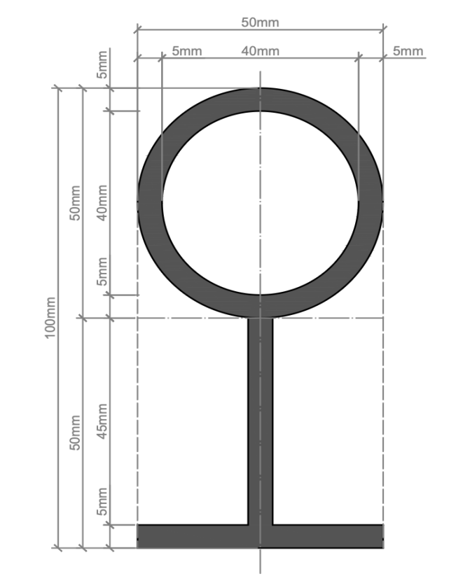

ANNEX C
(Clause 5.1.2)
DIGIPIN generation process
The following FIGs illustrate the complete procedure for generating DIGIPIN for a specific location. For example, the geographical coordinates of Dak Bhawan (28.622788°N, 77.213033°E) are marked with a red star on the India base map. The FIG below demonstrates the selection of DIGIPIN characters at each level, based on the grid for capturing the location of Dak Bhawan.
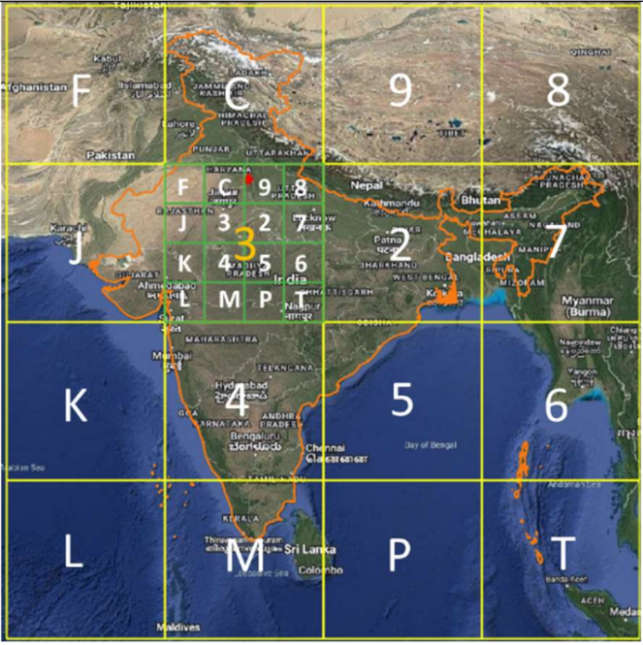 | 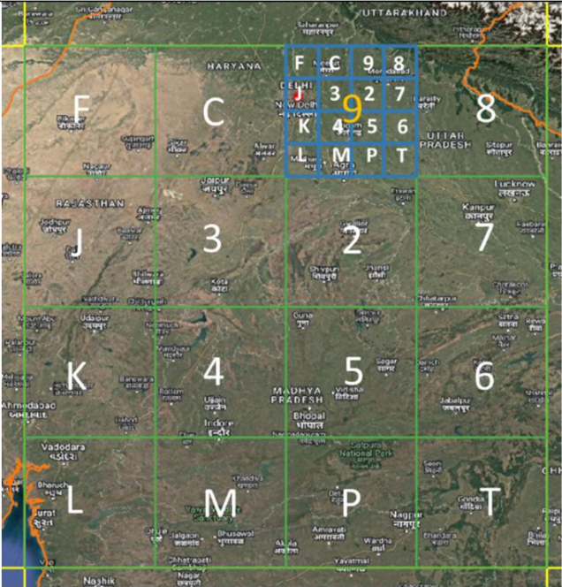
Level – 1  Character (3) | Level – 2  Character (9)

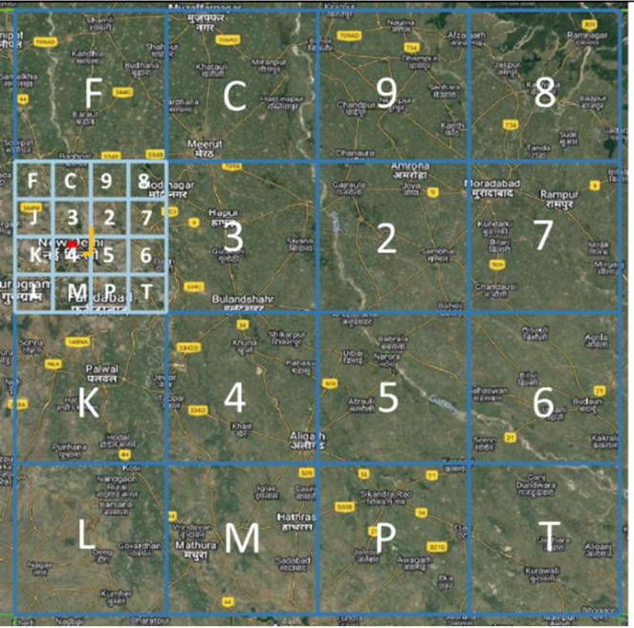 | 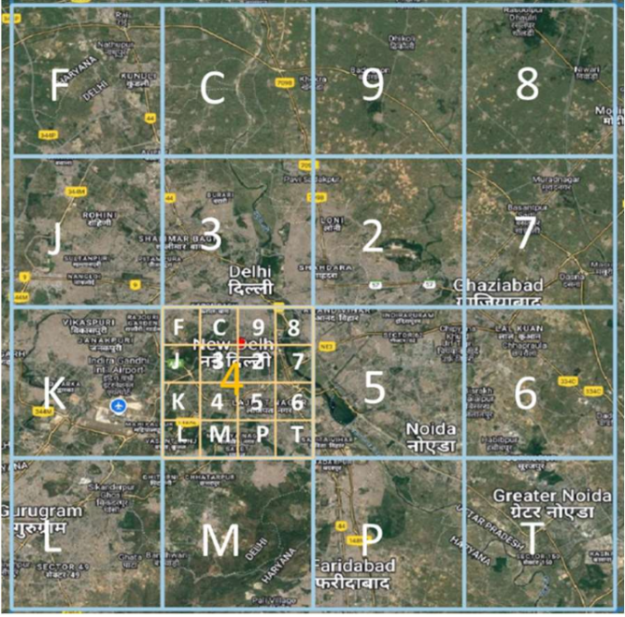
Level – 3  Character (J) | Level – 4  Character (4)

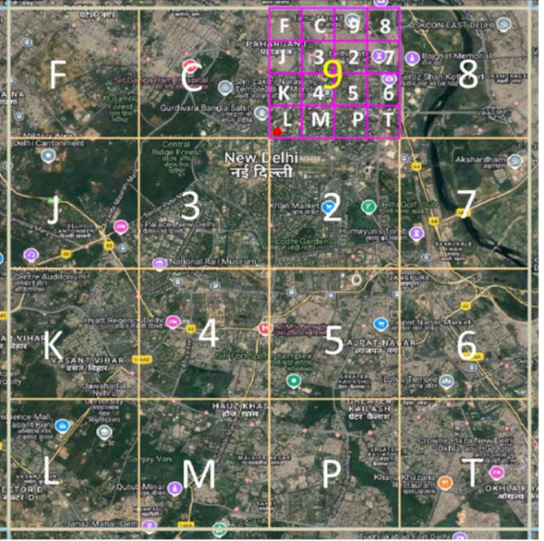 | 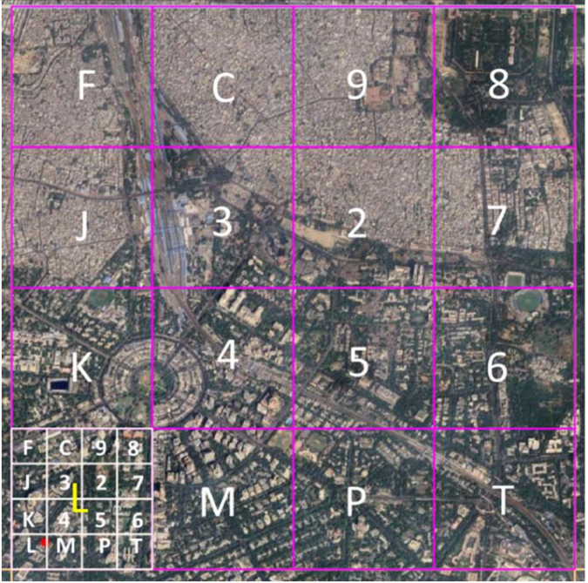
Level – 5  Character (9) | Level – 6  Character (L)

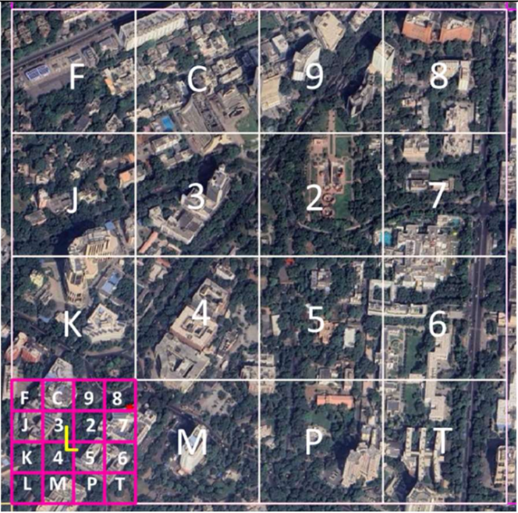 | 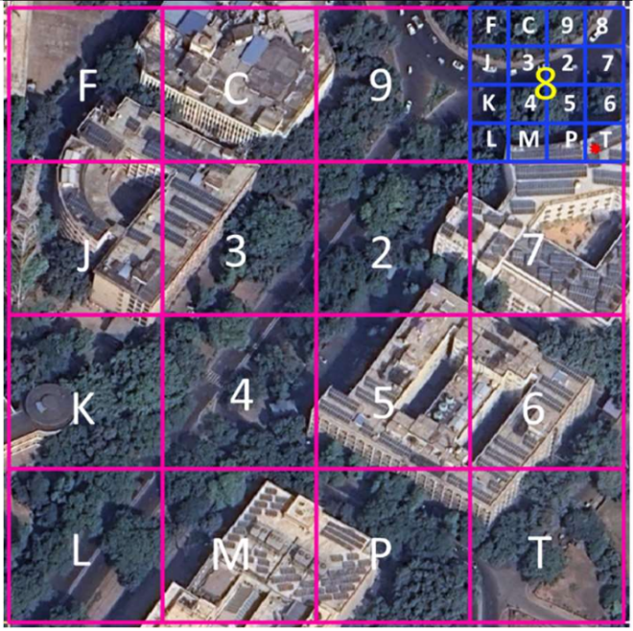
Level – 7  Character (L) | Level – 8  Character (8)

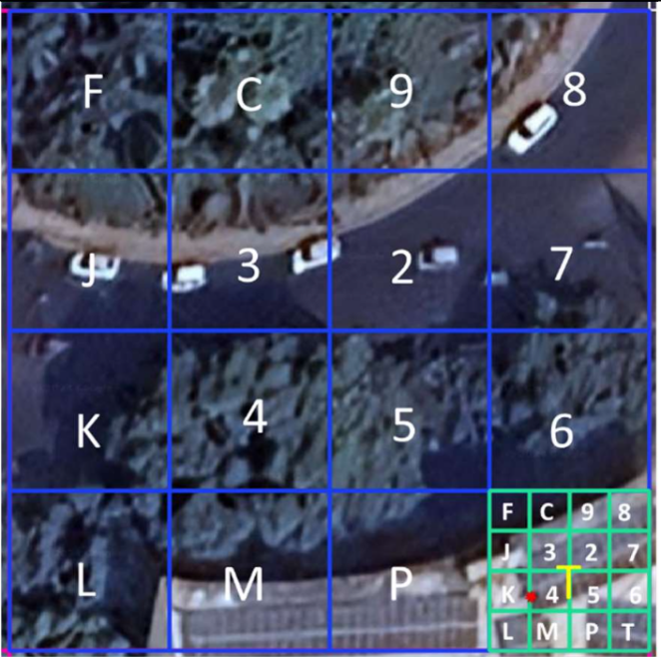 | 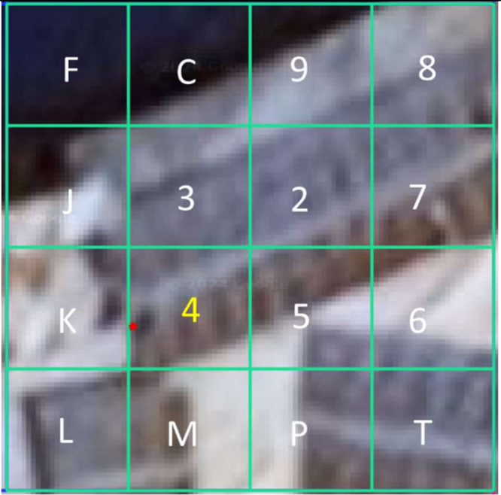
Level – 9  Character (T) | Level – 10  Character (4)
The illustration above displays the distinct character associated with each of the ten levels. Based on this, the DIGIPIN assigned to Dak Bhawan is 39J49LL8T4, which encodes its specific location information using the unique characters from all ten levels.

ANNEX D
(Clause 6.4)
Illustrations – DIGIPIN-enabled standardized way of writing an address
The illustrations below show how DIGIPIN-enabled addresses are written for different types of land use. Each example demonstrates the standardised way of writing an address, whether for a residence, an apartment unit, a commercial space, an office, or any other property type. The following are some illustrations of DIGIPIN-enabled addressing, the standardized way of writing an address for different land use –
Land use
The way in which a physical location of an address object or a parcel of land on the ground is utilized for different purposes:
Residential
Refers to the physical location of addressable objects used for the purpose of housing and residences. This can include houses with kitchen facilities, hostels, institutional accommodation, condominiums, etc.
Commercial
Refers to the physical location of addressable objects used for the purpose of business and trade which involves buying, selling or providing goods and services to consumers. This can include shopping centres, banks, hotels, etc.
Public Semi-Public
Refers to the physical location of addressable objects that are characterized by spaces, premises, facilities, or services that are publicly owned, operated, or accessible to the general public without restrictions. This can include Government buildings, offices, educational and health facilities, etc.
Industrial
Refers to the physical location of addressable objects that are used for the purpose of processing or manufacturing goods and commodities. This can include factories, manufacturing units, industries, etc.
Mixed-use
Refers to the physical location of an addressable object that includes multiple types of land uses within a single building, structure, or premises.

FIG F-1: Address sample – Rural Addresses

Fig F-2: Address sample – Residential (Individual home)
Fig F-3: Address sample - Residential (Builder floor)

Fig F-4: Address sample – Residential (Apartment building)
Fig F-5: Address sample – Residential (Group housing)

Fig F-6: Address sample – Commercial (Single retail shop)
Fig F-7: Address sample – Commercial (Shopping mall)

Fig F-8: Address sample – Public semi-public (Office building)
Fig F-9: Address sample – Mixed-use (Residential – Commercial)

FIG F-10: Address sample – Public semi-public (Government office)
FIG F-11: Address sample – Institutional (Community Hall)

FIG F-12: Address sample – Institutional (Hospital)
FIG F-13: Address sample – Institutional (School)

FIG F-14: Address sample – Industrial (Industry/ factory)

FIG F-15: Address sample – Others (Slums)

FIG F-16: Address sample – Others (Hostel)
FIG F-17: Address sample – Others (Hotel)

Based on Survey of India

