- Internet Explorer → Internet Options →
  - Click on the Security tab → Trusted Sites → click on Sites → add the URL - https://dpdcpfajapp.fsi.indiapost.gov.in:9000/SSO/ui/SSOLogin.jsp
  - In Trusted Site window, uncheck the “Require server verification(https: ) for all sites in this zone”
  - click on the Privacy tab → click on sites → add the domain as below screen shot
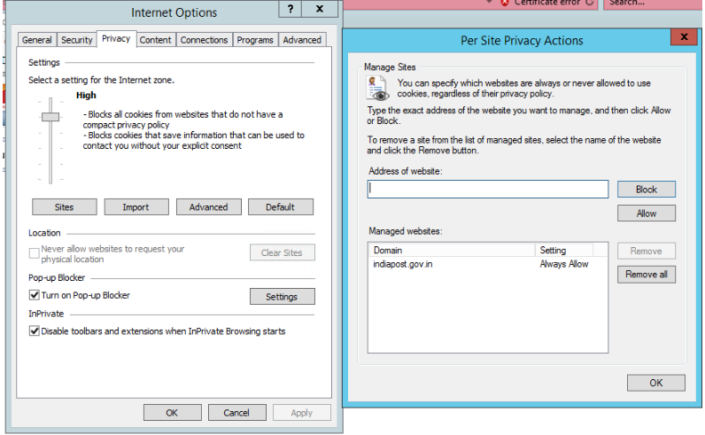

  - click on the Advanced tab → uncheck the highlighted parameters as below screenshot.
  - click on Apply and then OK to save the changes → restart IE and check the accessibility

