

SOP for New GDS Employee Creation


Standard Operating Procedure
APT

For New GDS Employee Creation

INDIA POST – Advance Postal Technology Page 1 of 10

SOP for New GDS Employee Creation

ABBREVIATIONS

Sl. No. | Abbreviation | Description
1 | OA | Office Assistant
2 | SP | Superintendent of Posts
3 | SSP | Senior Superintendent of Posts
4 | PIS | Personal Information System
5 | DoP | Department of Posts
6 | TOTP | Time Based One Time Password
7 | OTP | One Time Password

INDIA POST – Advance Postal Technology Page 2 of 10

SOP for New GDS Employee Creation

Standard Operation Procedure:

Area PIS
SOP No | 1
Module | Personal Information System
Dated | 09.03.2026
SOP Title | New GDS Employee Creation

INDIA POST – Advance Postal Technology Page 3 of 10

SOP for New GDS Employee Creation

Introduction
This Standard Operating Procedure (SOP) outlines the process for creating new employee records for GDS employees. Employee creation responsibilities are designated based on administrative levels: at the Division Level, the Divisional Office Assistant is authorized to create employee profiles, while at the Circle/Regional Level, this task is carried out by the Office Assistant.

User Login
Production / Live URL: https://app.indiapost.gov.in/employeeportal





After entering the URL in the address bar of a recommended web browser, the login screen will appear as shown above.

Enter the Employee ID and Password. Then click ‘Sign In’.

INDIA POST – Advance Postal Technology Page 4 of 10

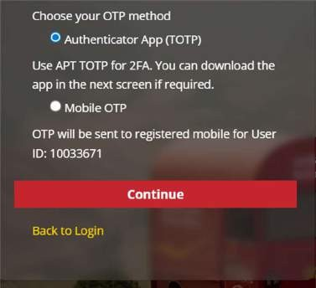

SOP for New GDS Employee Creation

Upon clicking ‘Sign In’, the user is required to log in to the application using one of the following authentication methods:

  - TOTP Method

  - Mobile OTP Method.

INDIA POST – Advance Postal Technology Page 5 of 10

SOP for New GDS Employee Creation

Roles Required
For the Creation of new employee, the below mentioned Roles shall be given to the identified users.

  - For Maker: Dealing Assistant(Maker for employee management)
  - For Checker: Service Book Supervisor(SP/SSP)
It is strictly advised not to assign the Maker role to the same individual designated as the Checker.

Creation of New Employee

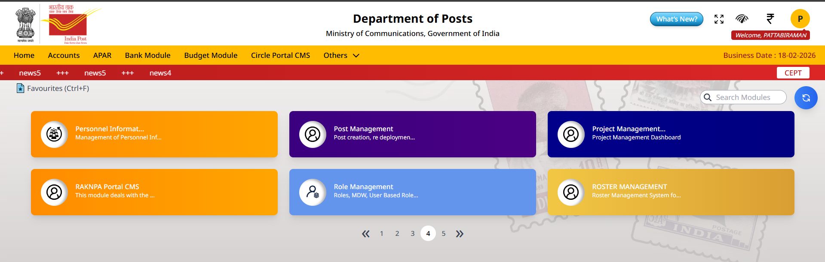
Click ‘Personal Information System’ Card.
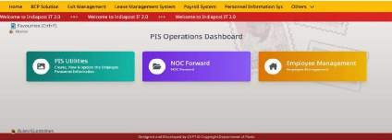
Upon clicking ‘PIS’ Card, the PIS Operations Dashboard will be displayed. Click ‘Employee Management’ sub-card.

INDIA POST – Advance Postal Technology Page 6 of 10

SOP for New GDS Employee Creation

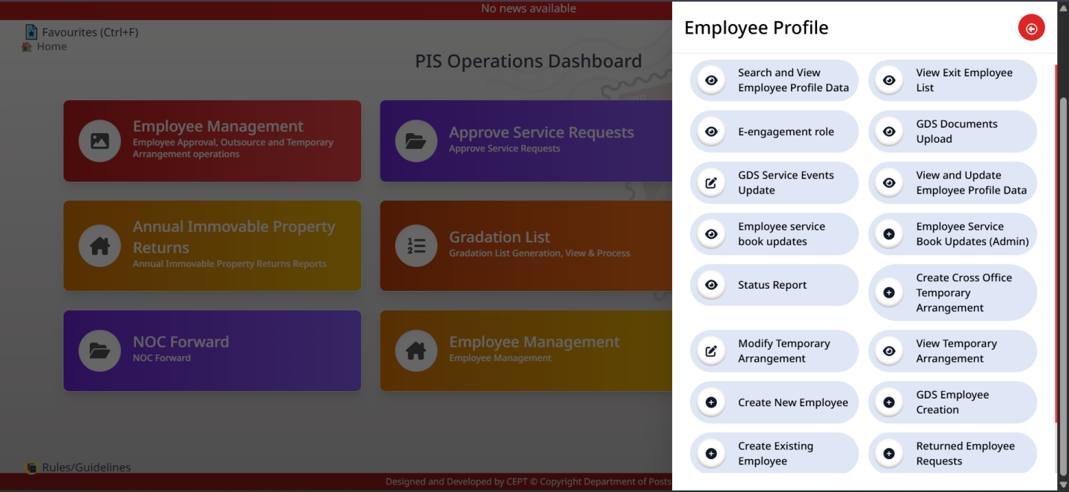

Upon clicking the ‘Employee Management’ sub-card, the Options will be displayed under Employee Profile.

Click ‘GDS Employee Creation’ option.

Upon clicking the ‘GDS Employee Creation’ option, the ‘Employee Personal Information’ screen will be displayed, showing the records of GDS employees available for creation.
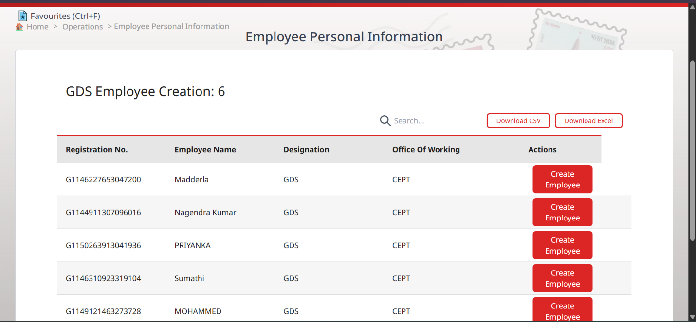

INDIA POST – Advance Postal Technology Page 7 of 10

SOP for New GDS Employee Creation

Upon clicking the ‘Create Employee’ option, the ‘Employee Personal Information’ screen will be displayed. The user is required to fill in the necessary details that are not auto fetched in the following three stages:
  - Personal Information
  - Communication Details
  - Posting Information

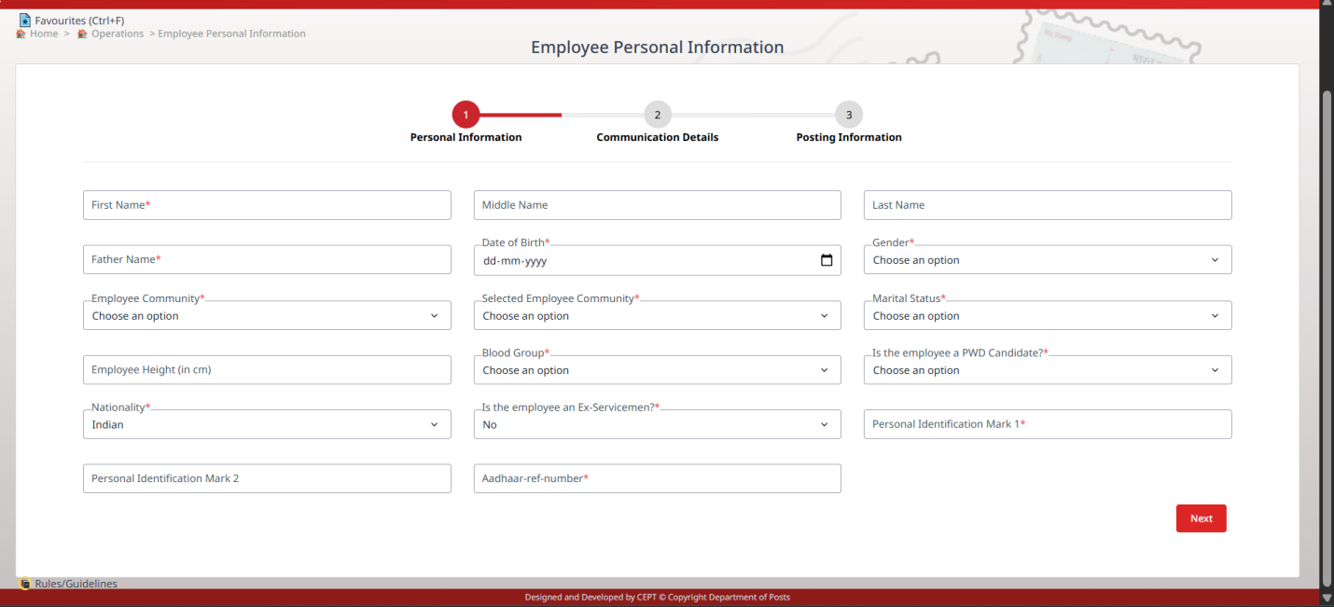

Upon filling all mandatory fields under ‘Personal Information’, Click ‘Next’ button.
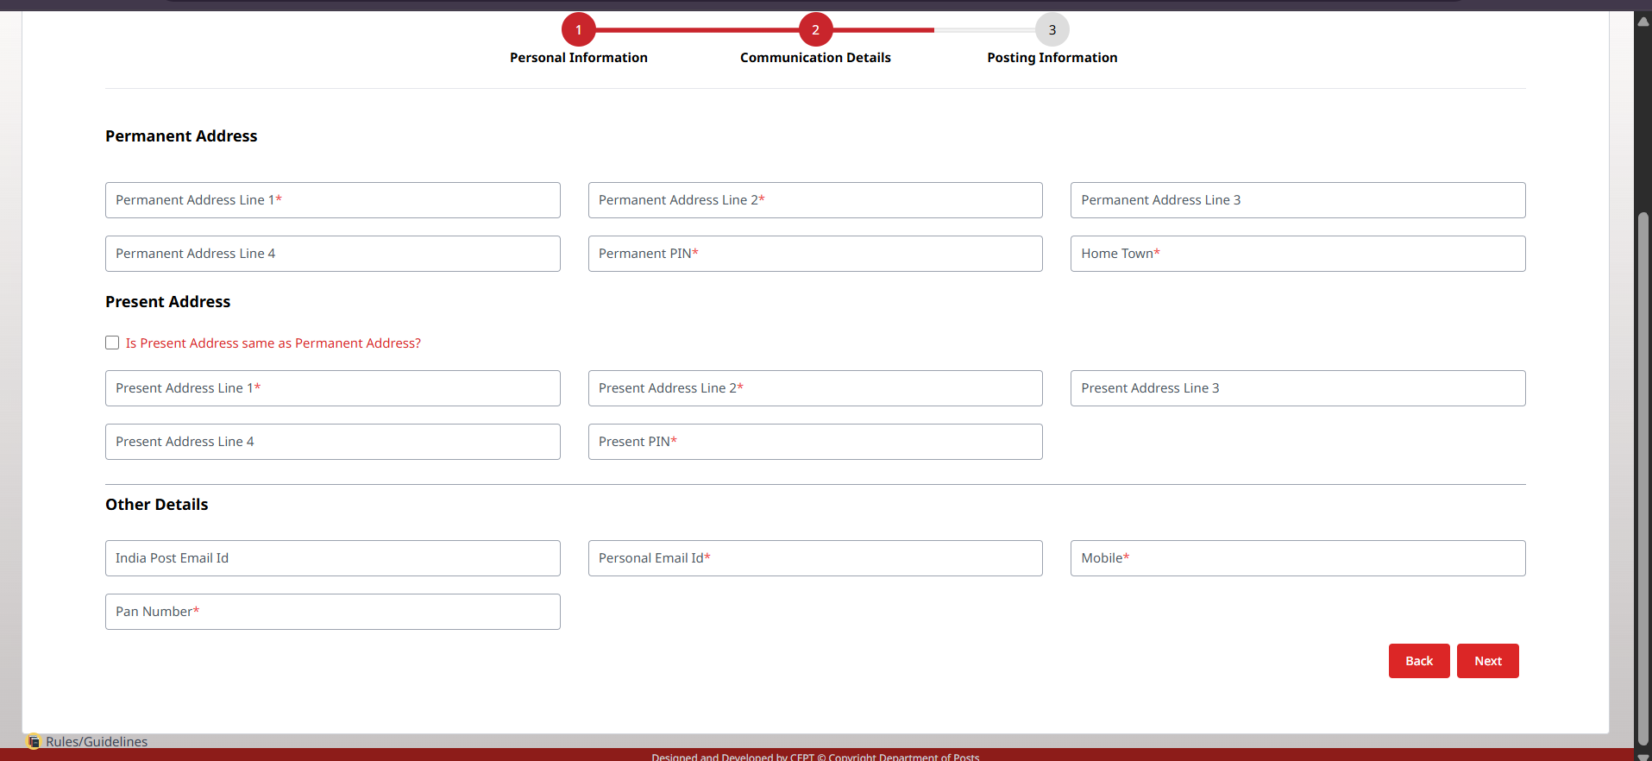
INDIA POST – Advance Postal Technology Page 8 of 10

SOP for New GDS Employee Creation

Upon clicking the ‘Next’ button, the user needs to fill all the mandatory fields under ‘Communication Details’.

Click ‘Next’ button.

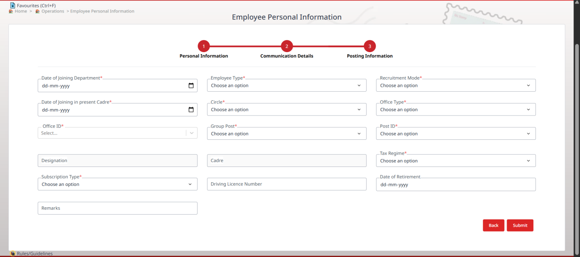

Finally, the user needs to fill the Posting Information fields and Click ‘Submit’ button. Upon clicking the ‘Submit’ button, the new Employee ID will be generated.

Approval of Newly Created Employee
The employee ID created at the Maker Level needs to be verified at the Checker level.

SOP for New GDS Employee Creation

After login by the Checker, Click on ‘Personal Information System’ card.

Click ‘Employee Management’ sub-card.

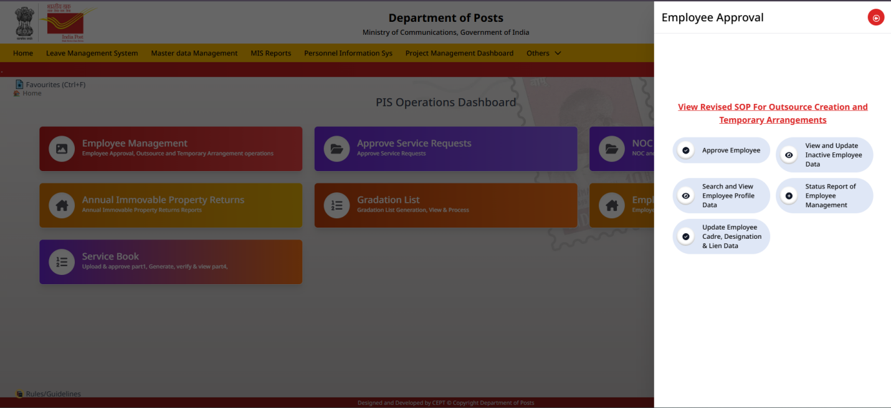

Upon clicking the ‘Employee Management’ sub-card, click on ‘Approve Employee’ Option.
The newly created employee details will be displayed. Verify the Data and approve.

INDIA POST – Advance Postal Technology Page 10 of 10

