Standard Operating Procedure
For
Post Creation & Post Verification

Standard Operating Procedure

Area | Post Management
SOP No | 1
Module | Post Management System
Dated | 22.03.2026
SOP Title | Post Creation & Verification

1. Introduction

This Standard Operating Procedure (SOP) outlines the processes for creation of Posts in the India Post - Post Management System.
It covers the following operations:
1. Post Creation – Creating a new Post ID
2. Post Verification – Approval/Rejection of created Post

2. User Login

Production / Live URL: https://app.indiapost.gov.in/employeeportal
Step 1: Enter Employee ID and Password, then click Sign In.
Step 2: Authenticate using TOTP or Mobile OTP.
Step 3: After successful authentication, dashboard will appear.

3. Roles Required

Sl No | Role | Authorized Level
1 | Post Create Maker | Directorate, CEPT and Circle
2 | Post Create Checker | Directorate, CEPT and Circle

4. Post Creation
Required Role: Post Create Maker under Post Management.
Circle users with this role can create a Post ID within their respective Circle.
Step 4: Navigate to Post Management module. Click on Post Creation card
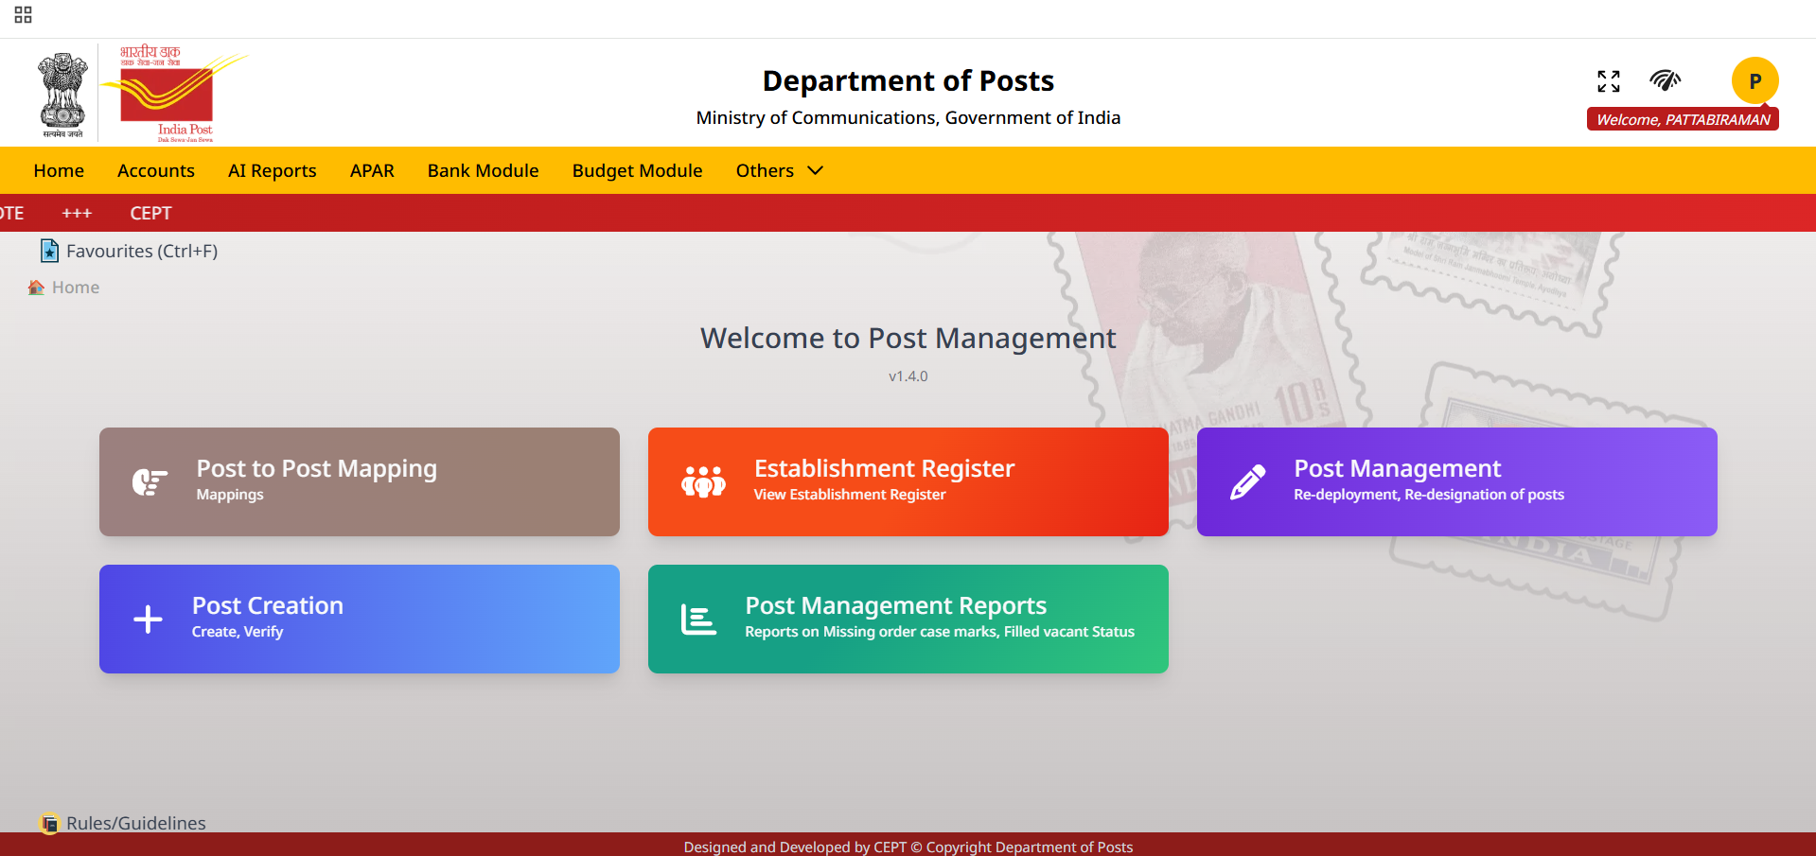
Step 5: Click Create Post button on the right.
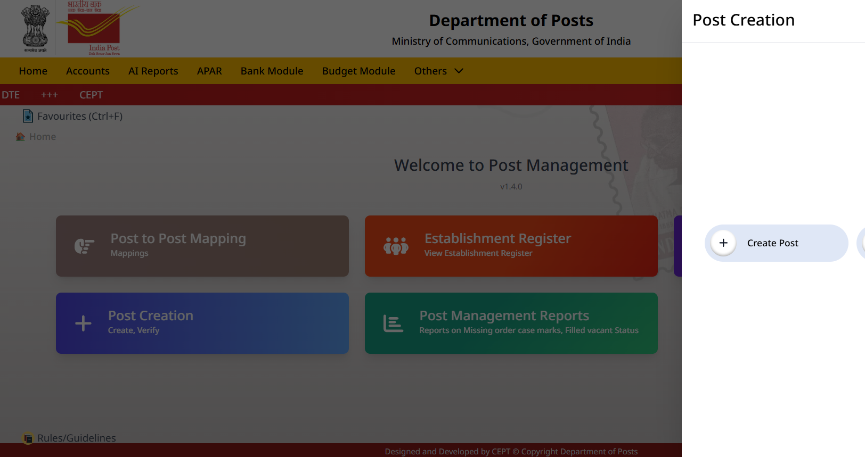
Step 6: Search and select the office wherein the post id is to be created using the Office Search. Fill all mandatory fields.
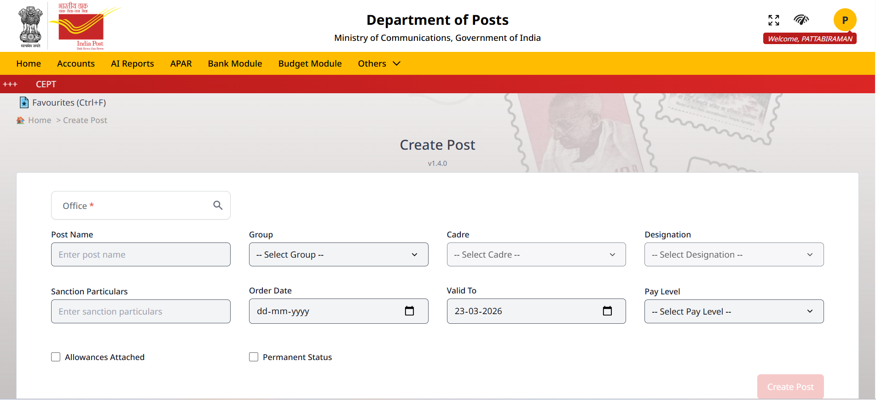

Step 7: Click Create Post button.
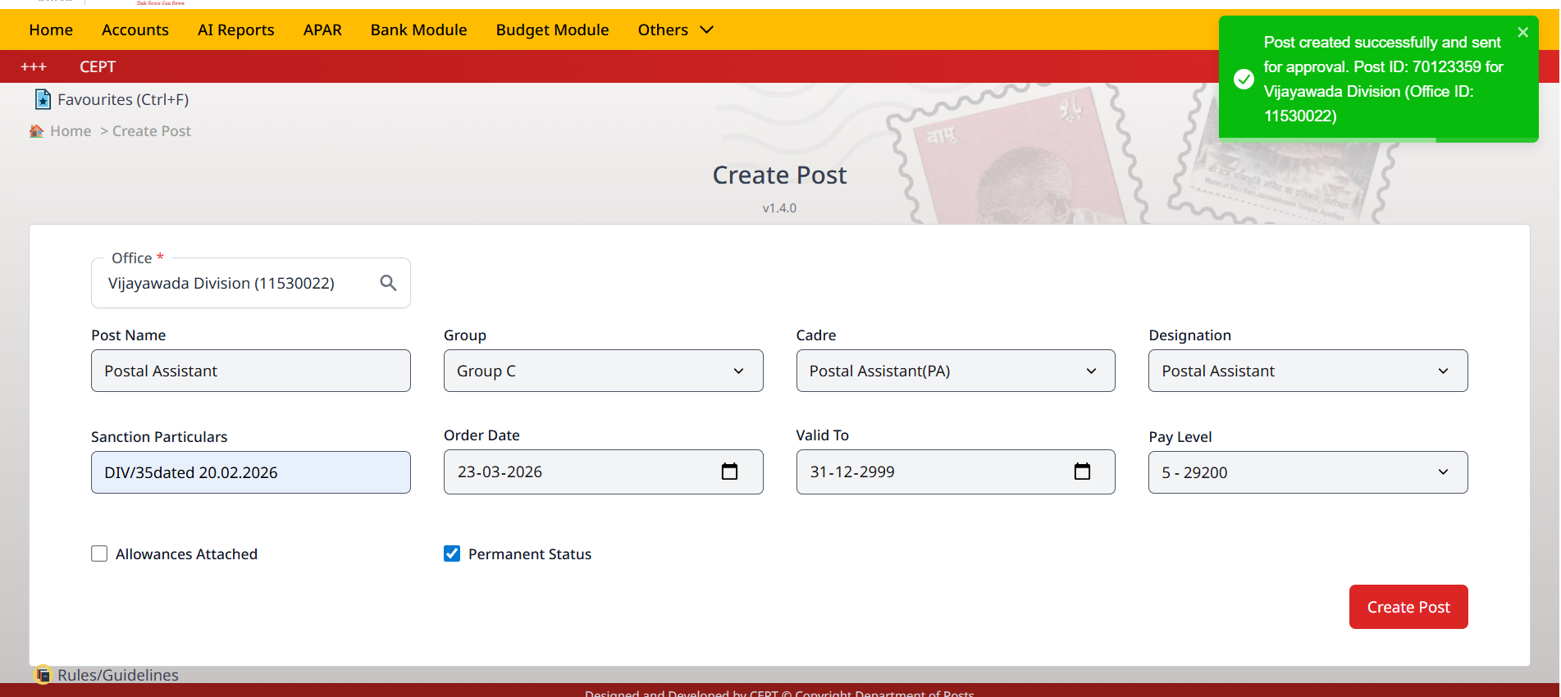
Step 8: Post ID will be generated and sent for approval.

5. Post Verification / Approval
Required Role: Post Create Checker role is to be allotted to checker. Ensure that the Maker and Checker roles are not assigned to the same user. Circle users with this role can verify a Post ID within their respective Circle.
Step 9: Login as Checker. Go to the Verify Created Post option, the system displays the list of posts that have been created and are pending for verification.
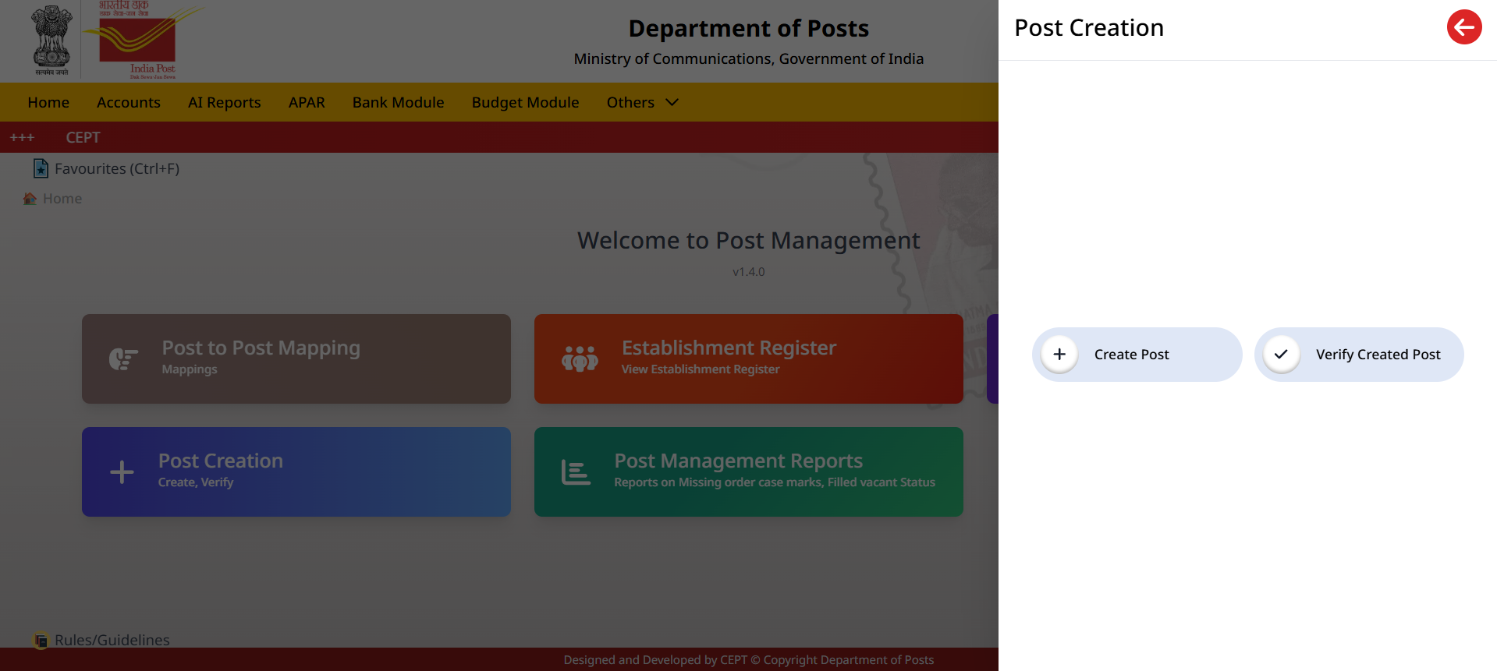
Step 10: Select post from pending list.
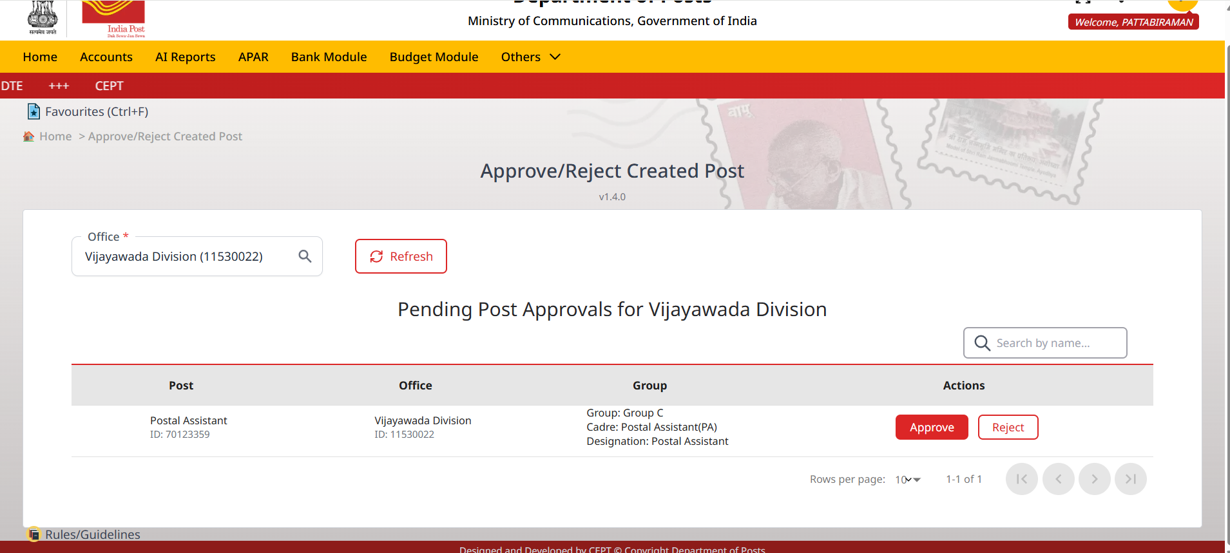

Step 12: Verify details and confirm.

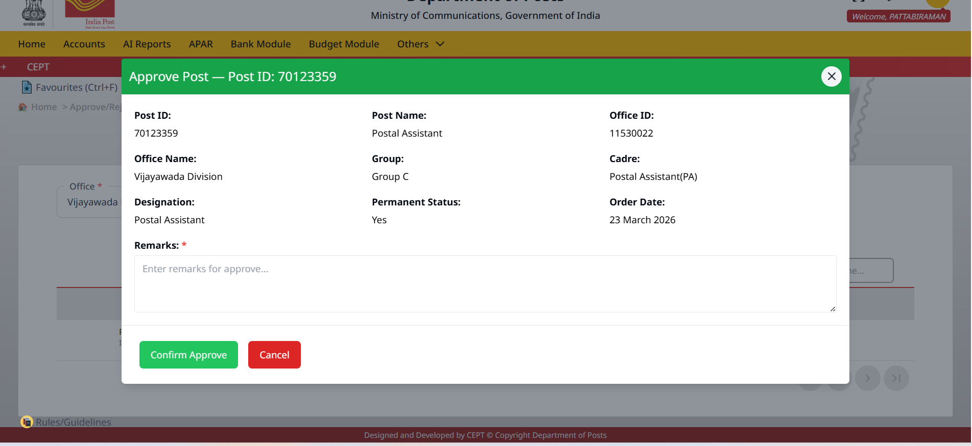
Step 13: If all the above details are correct, enter appropriate remarks and click Confirm Approve. Otherwise, cancel the screen and choose the Reject option.

